# Assignment 2

## Introduction:

In this assignment, the objective was to investigate the impact of training sample size on the performance of convolutional neural networks (convnets) in the context of classifying Cats & Dogs images. Two primary approaches were explored: training a network from scratch and using a pretrained convnet. The investigation involved varying training sample sizes and optimizing the models to improve performance.

## Methodology:

### Training from Scratch COVNET Model:

**a. Initial Setup (Step 1):**

Training Sample Size: 1000

Validation Sample Size: 500

Test Sample Size: 500

Techniques: Data augmentation and regularization were employed to reduce overfitting.

Model Summary:

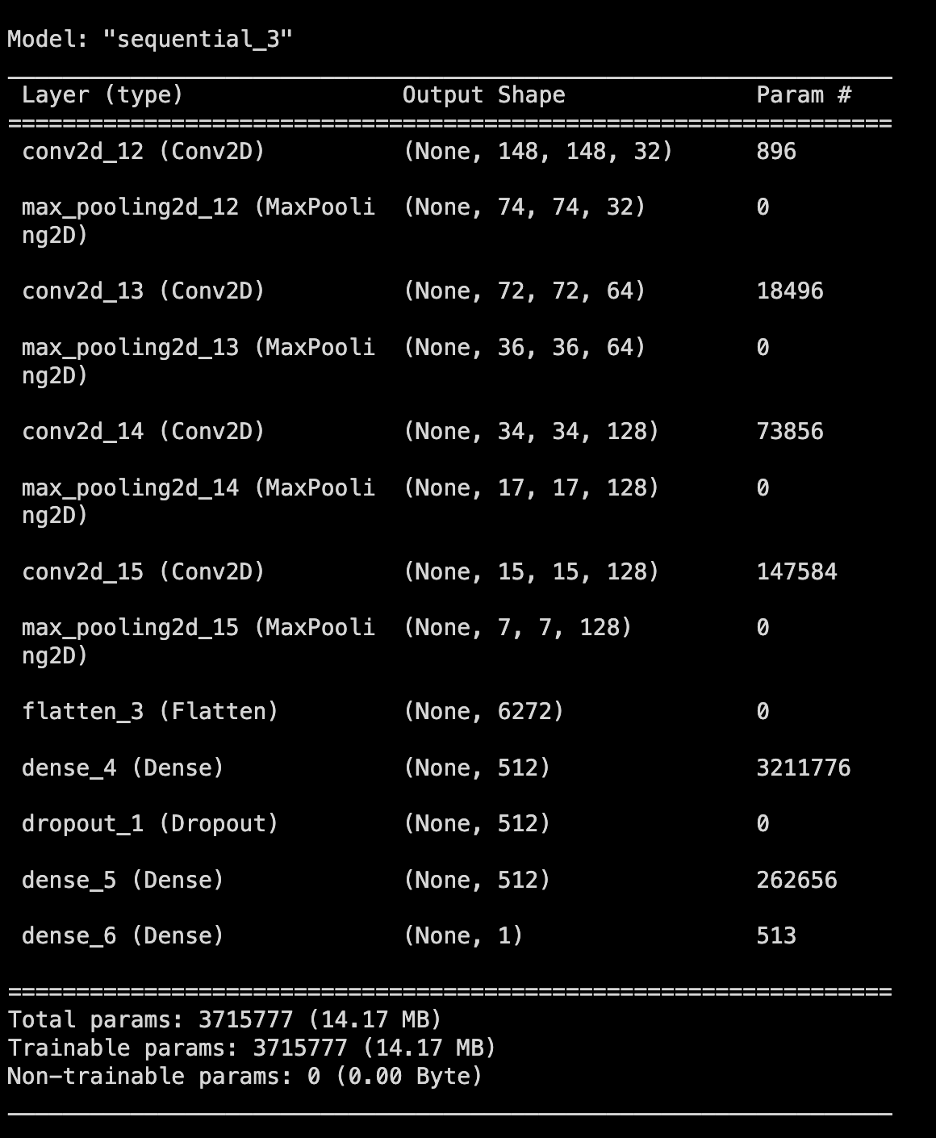

**b. Performance (Step 1):**

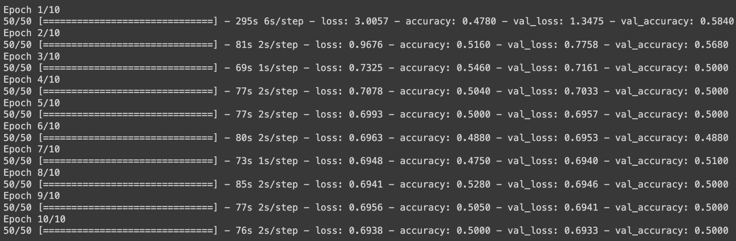

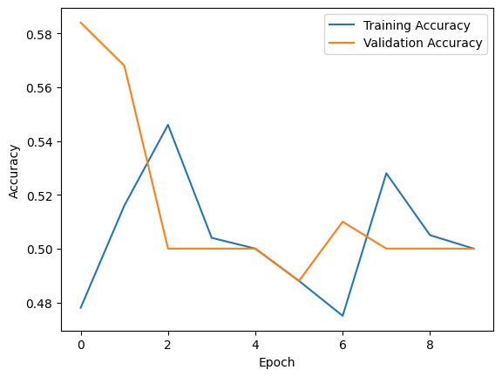

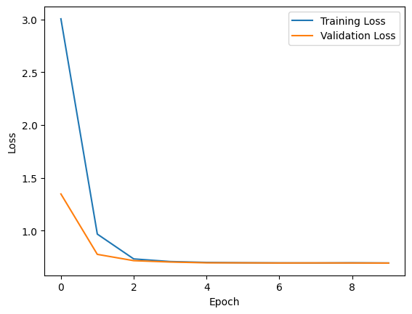

**Accuracy:** Achieved accuracy of 50% on the test set.



**c. Increase in Training Sample Size (Step 2):**

Increased training sample size =1800

Validation Sample Size: 500

Test Sample Size: 500

Techniques: Data augmentation and regularization were employed to reduce overfitting.

Model Summary:

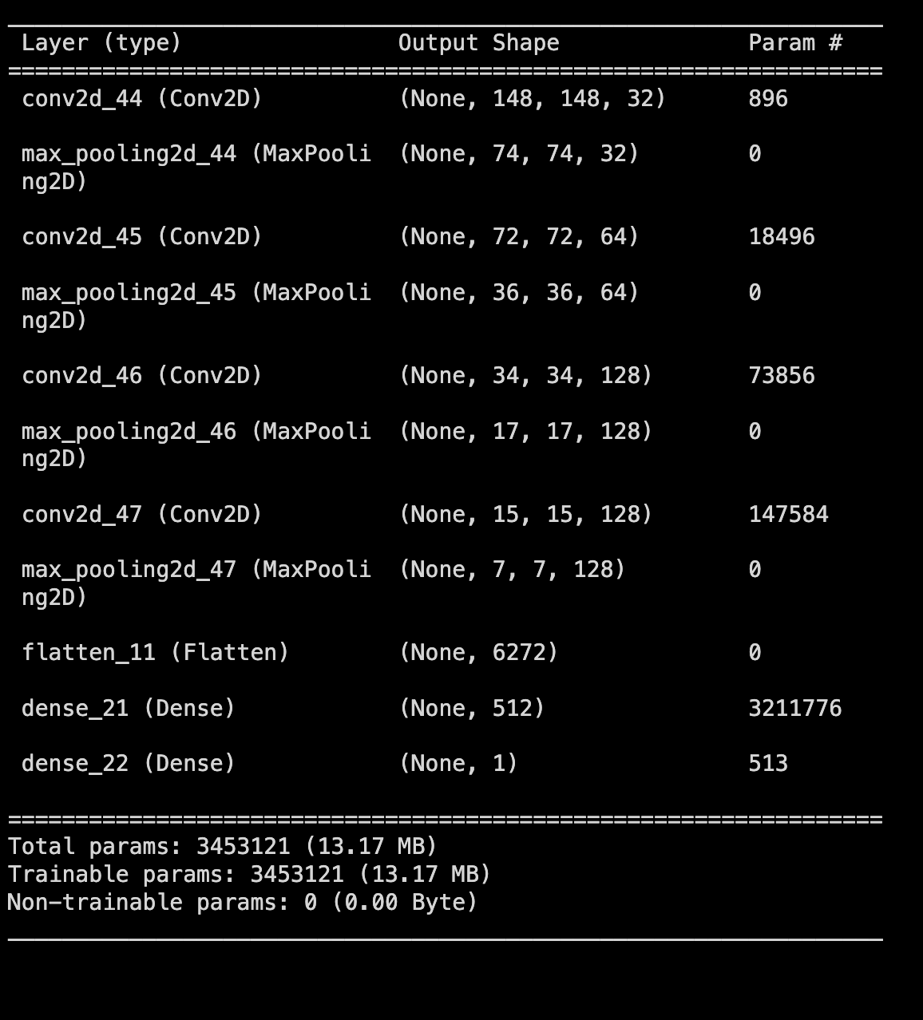

**d. Performance (Step 2):**

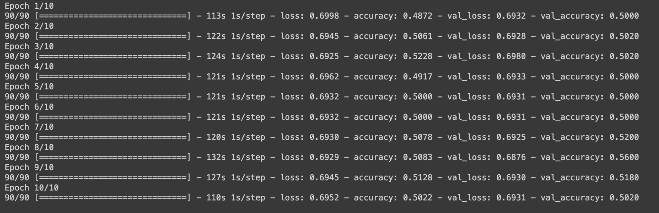



**Accuracy:** Achieved accuracy of 49.80% on the test set.

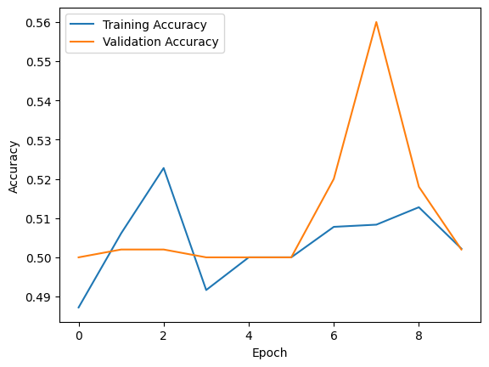

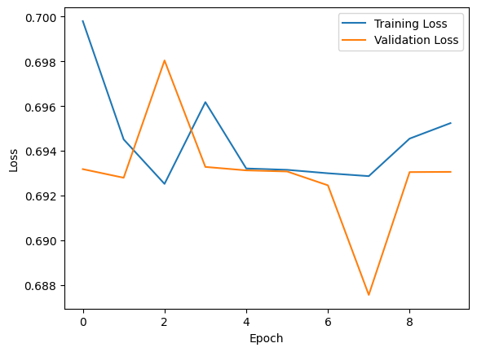

**e. Optimal Training Sample Size (Step 3):**

Further adjustments to training sample size to find the ideal size for improved performance.

Increased training sample size =1500

Validation Sample Size: 500

Test Sample Size: 500

Techniques: Data augmentation and regularization were employed to reduce overfitting.

**Model Summary:**

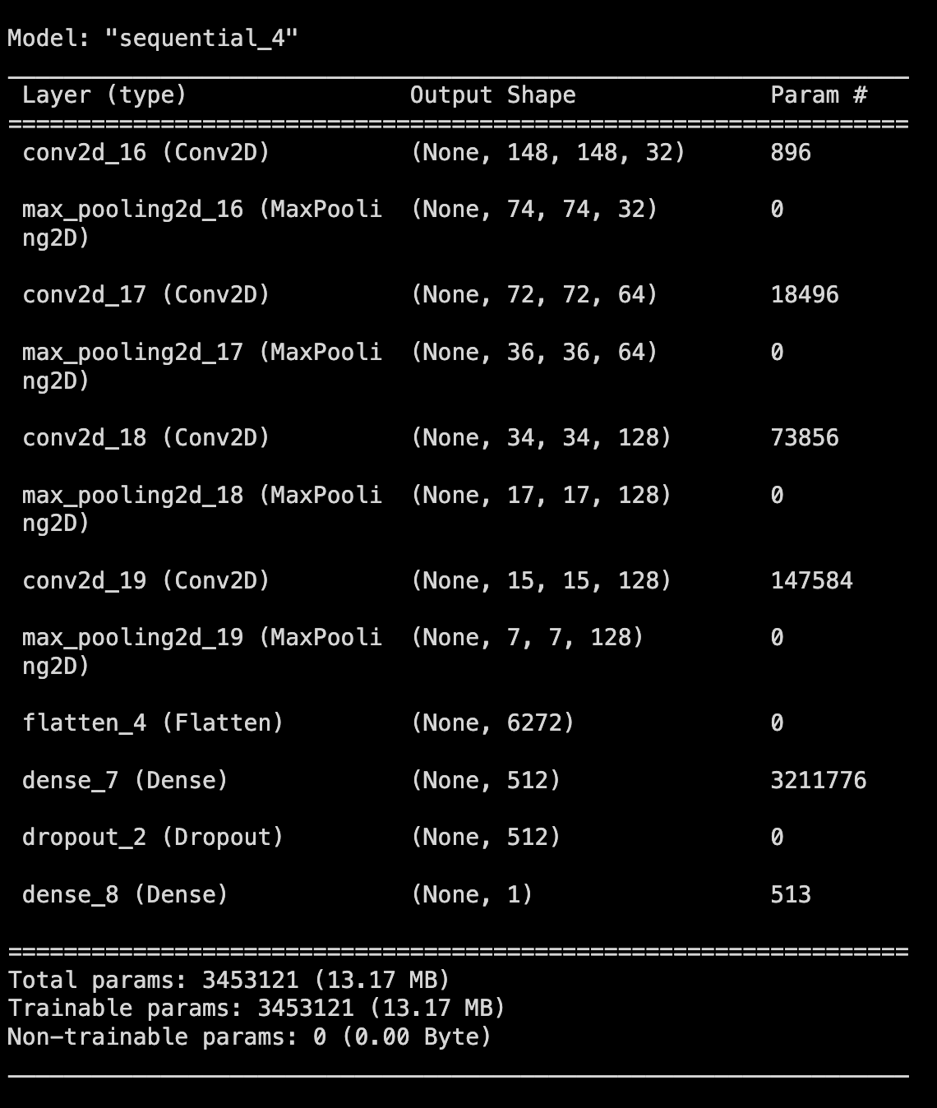

**f. Performance (Step 3):**

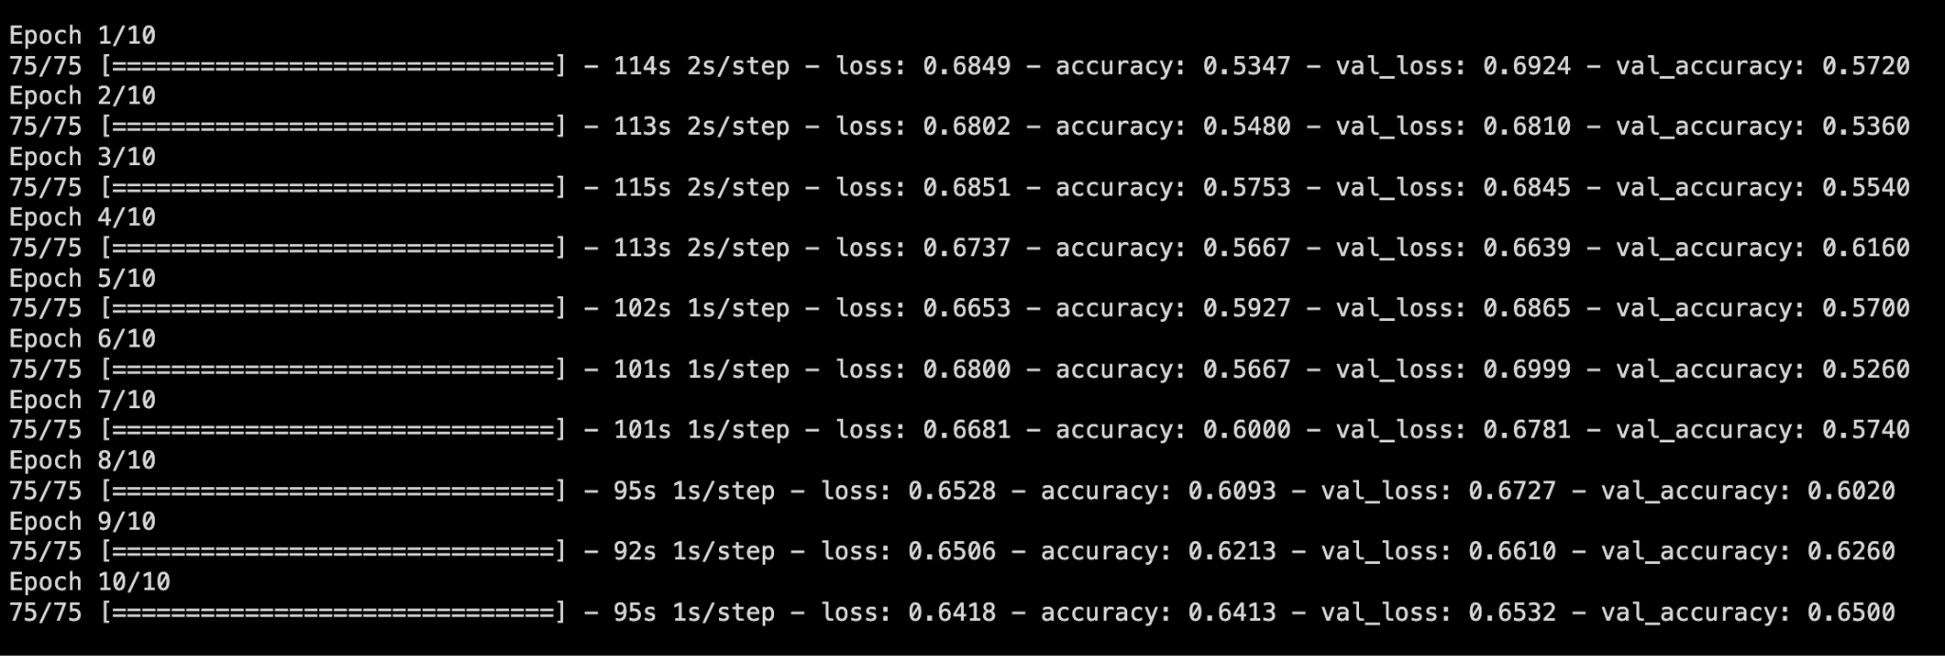



**Accuracy:** Achieved accuracy of 65.80% on the test set.

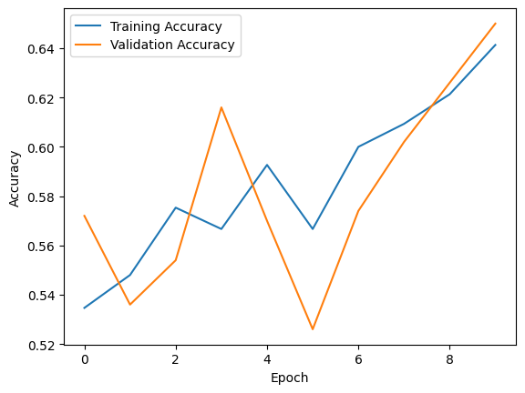

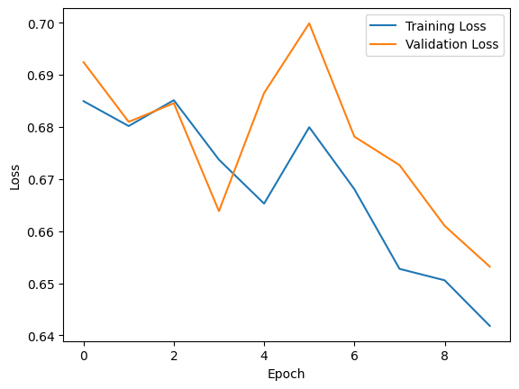

### **Using a Pretrained Network:**

a. Repeat Steps 1-3 with Pretrained Network:

Utilized a pretrained convnet for the same sample sizes used in Steps 2 and 3 of training from scratch.

Employed optimization techniques to enhance performance.

b. Performance with Pretrained Network:

**Step 1: Sample Size: 1000**

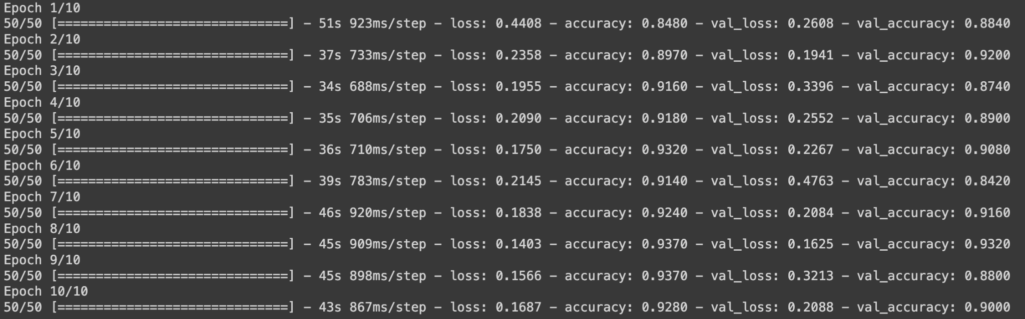



Accuracy: Achieved accuracy of 91% on the test set.

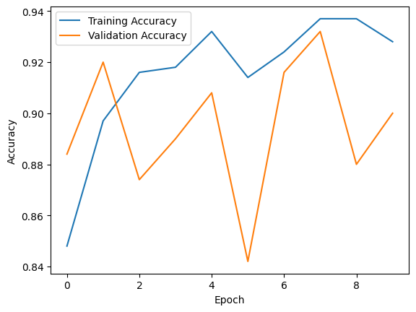

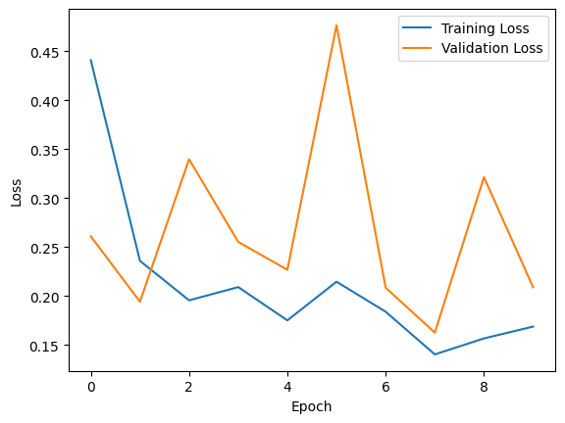

**Step 2: Sample Size: 1800**

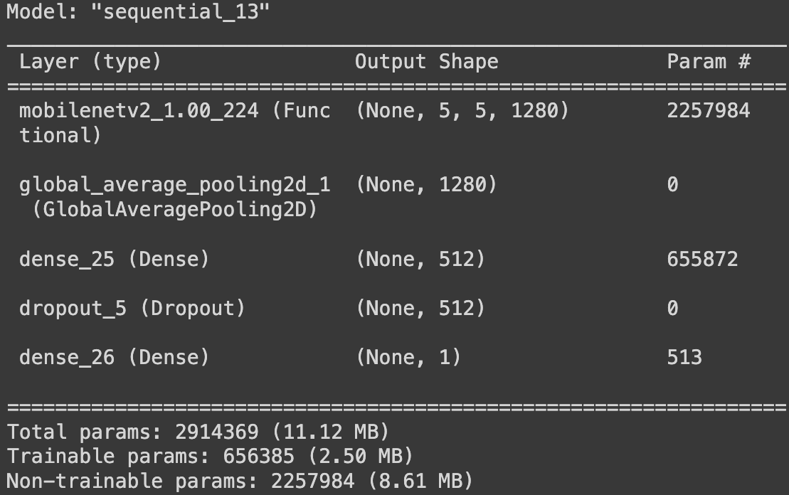

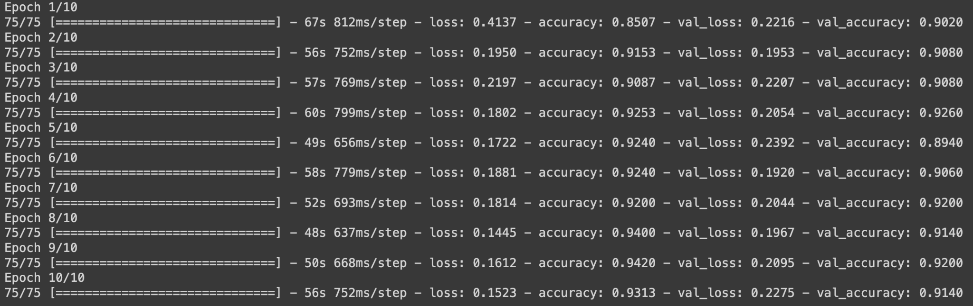

Accuracy: Achieved accuracy of 92.60% on the test set.



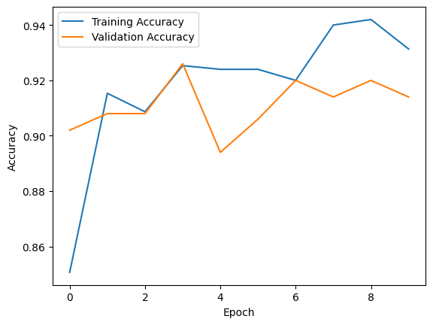

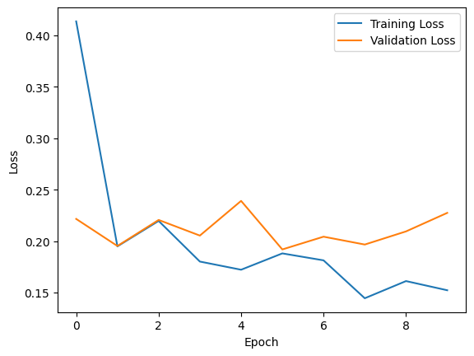

**Step 3: Sample Size: 1500**

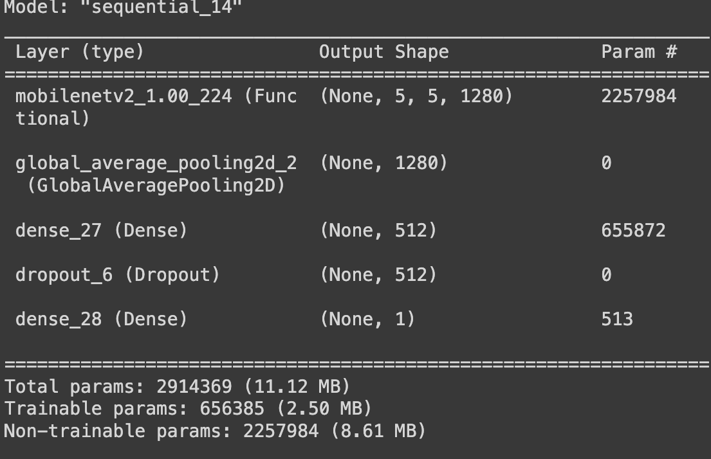

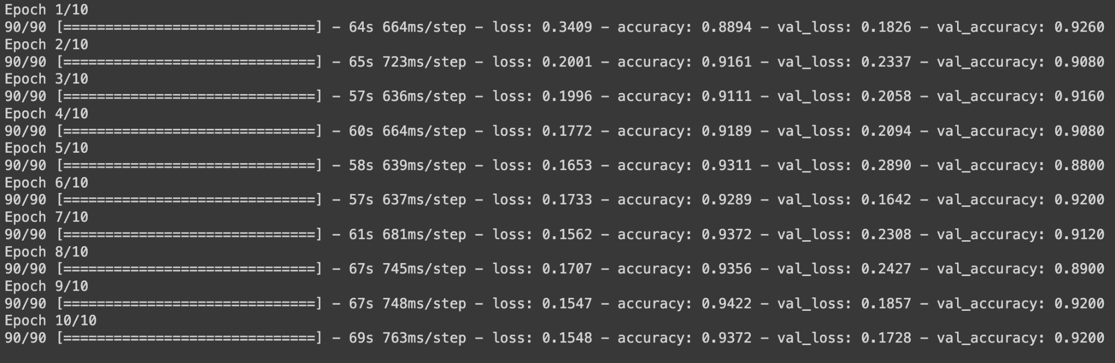

Accuracy: Achieved accuracy of 93.20% on the test set.



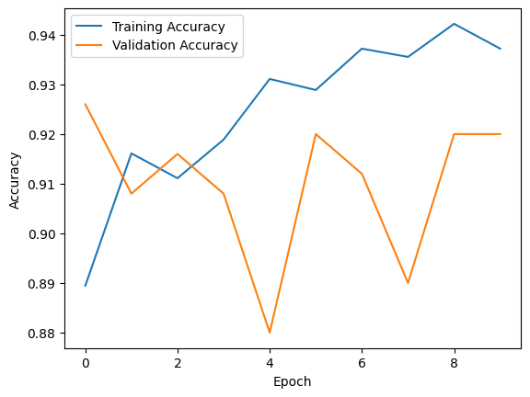

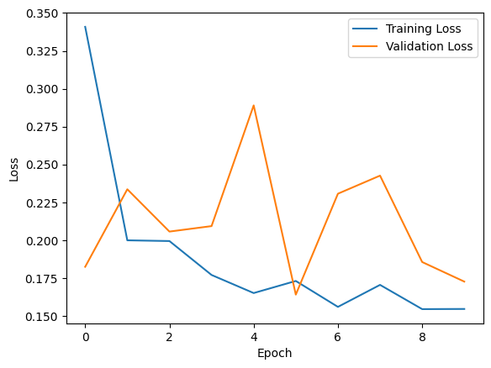

### **Findings:**

**Training from Scratch:**

Achieving the optimal training sample size led to improved accuracy.

Data augmentation and regularization were crucial in mitigating overfitting.

**Using a Pretrained Network:**

Pretrained networks generally outperformed scratch-trained networks.

The impact of training sample size on performance was still observed, but pretrained networks were more robust to smaller datasets.

Transfer learning proved effective in leveraging knowledge from pretrained models.

Relationship between Training Sample Size and Network Choice:

The relationship between training sample size and network choice is evident in the following observations:

**Training from Scratch:**

Optimal training sample sizes were critical for achieving the best results.

**Using a Pretrained Network:**

Pretrained networks demonstrated higher resilience to smaller training sample sizes.

Transfer learning allowed the model to leverage knowledge from the pretrained architecture, yielding superior performance compared to training from scratch.

## Summary

In conclusion, the choice of network, whether training from scratch or using a pretrained convnet, is influenced by the available training sample size. Larger datasets benefit both approaches, but pretrained networks offer a robust solution when faced with limited training data. Understanding the relationship between sample size and network choice is crucial for achieving optimal performance in image classification tasks, as depicted from the table below:

**COVNET MODEL (Made from scratch)**

|  |  |  |
| --- | --- | --- |
| **Sample Size** | **Testing Accuracy** | **Test Loss** |
| 1000 | 50% | 0.69 |
| 1800 | 49.80% | 0.69 |
| 1500 | 65.80% | 0.62 |

**Pre-Trained MODEL (Made from scratch)**

|  |  |  |
| --- | --- | --- |
| **Sample Size** | **Testing Accuracy** | **Test Loss** |
| 1000 | 91% | 0.19 |
| 1800 | 92.60% | 0.16 |
| 1500 | 93.10% | 0.17 |